AIRPLANE
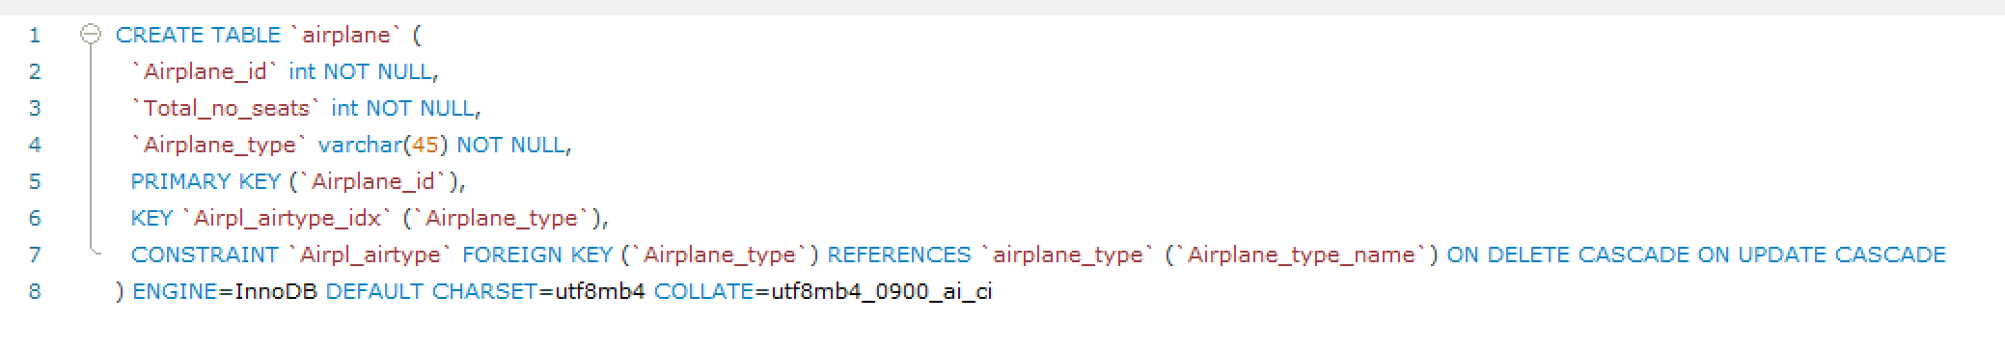
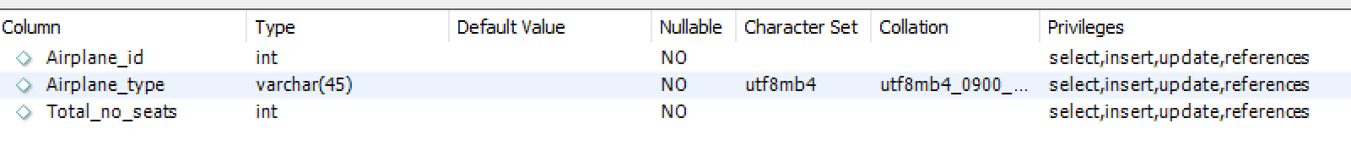
AIRPLANE_TYPE
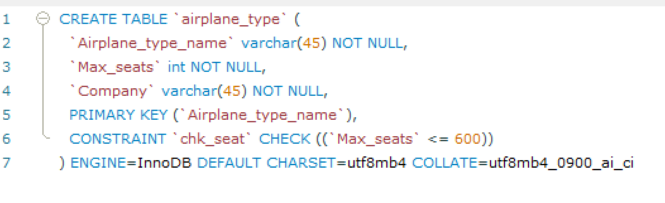
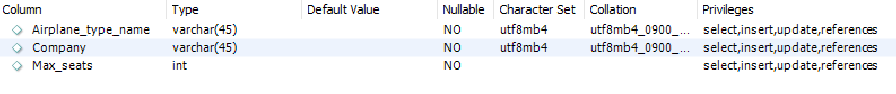
AIRPORT
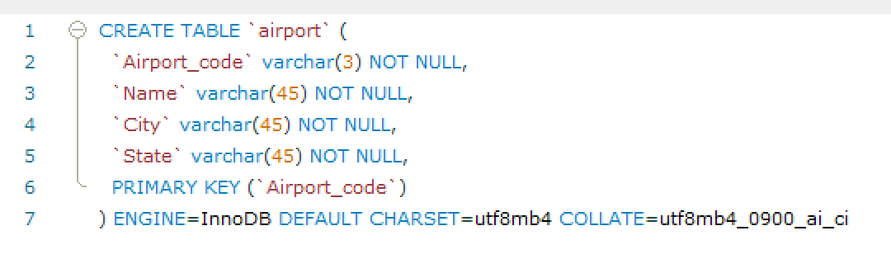
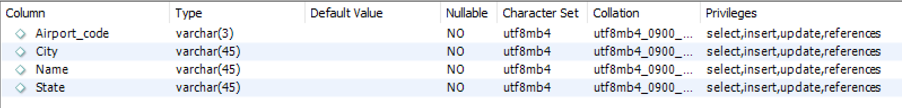
CAN_LAND
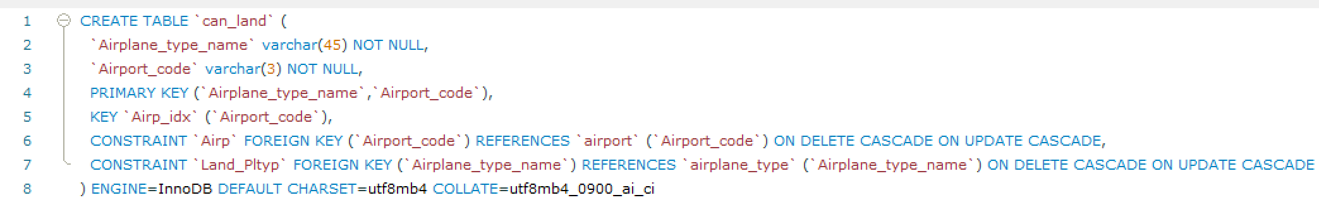
FARE
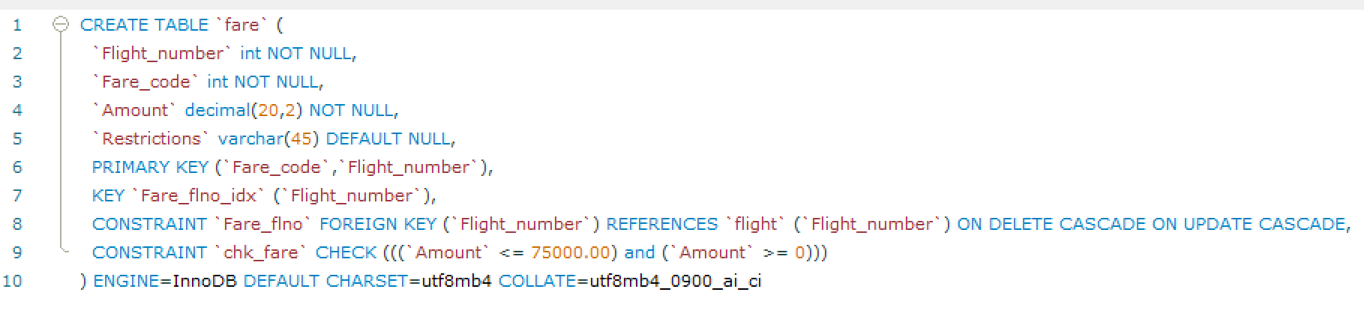
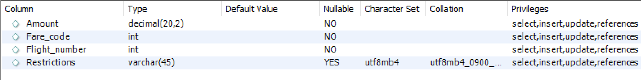
FLIGHT
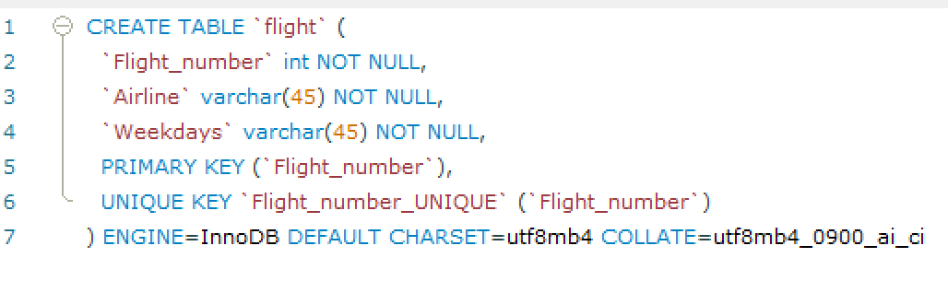
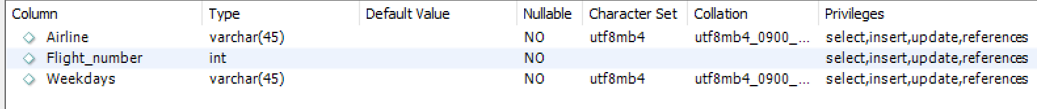

FLIGHT_LEG
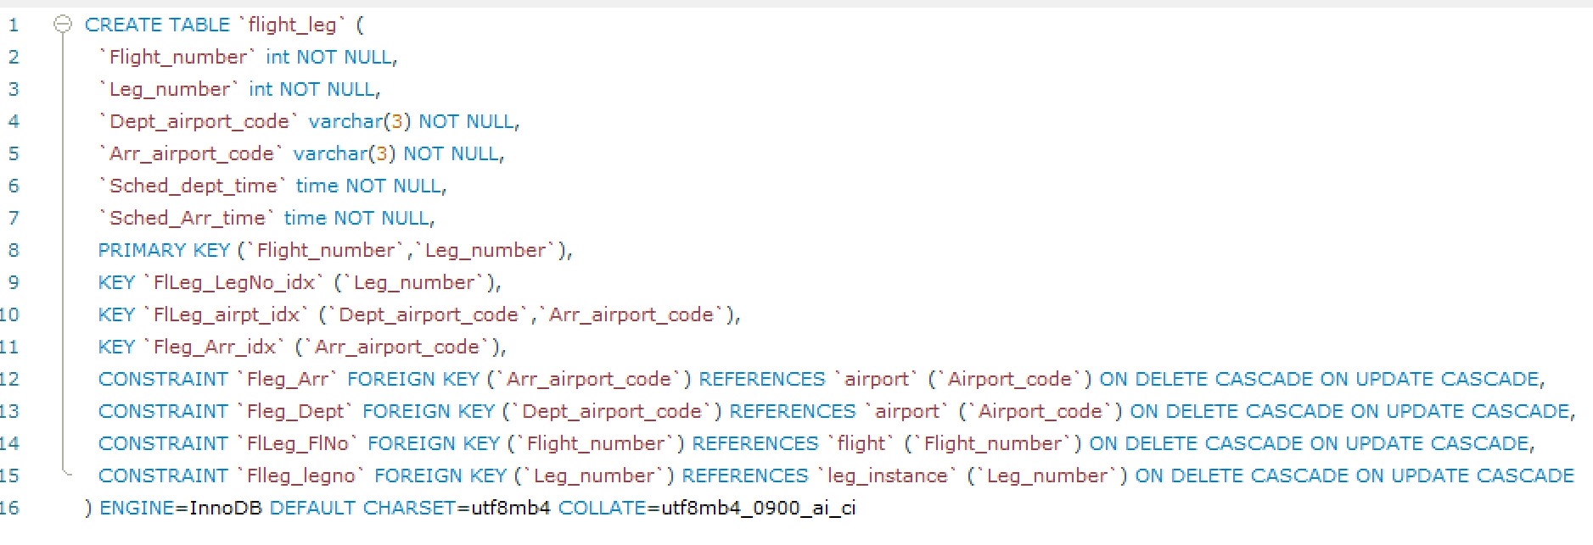
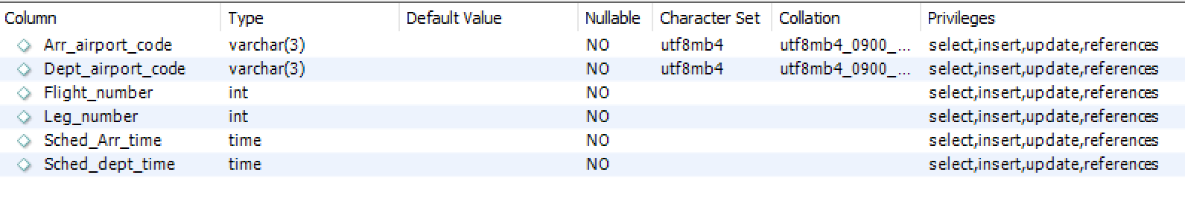

LEG_INSTANCE
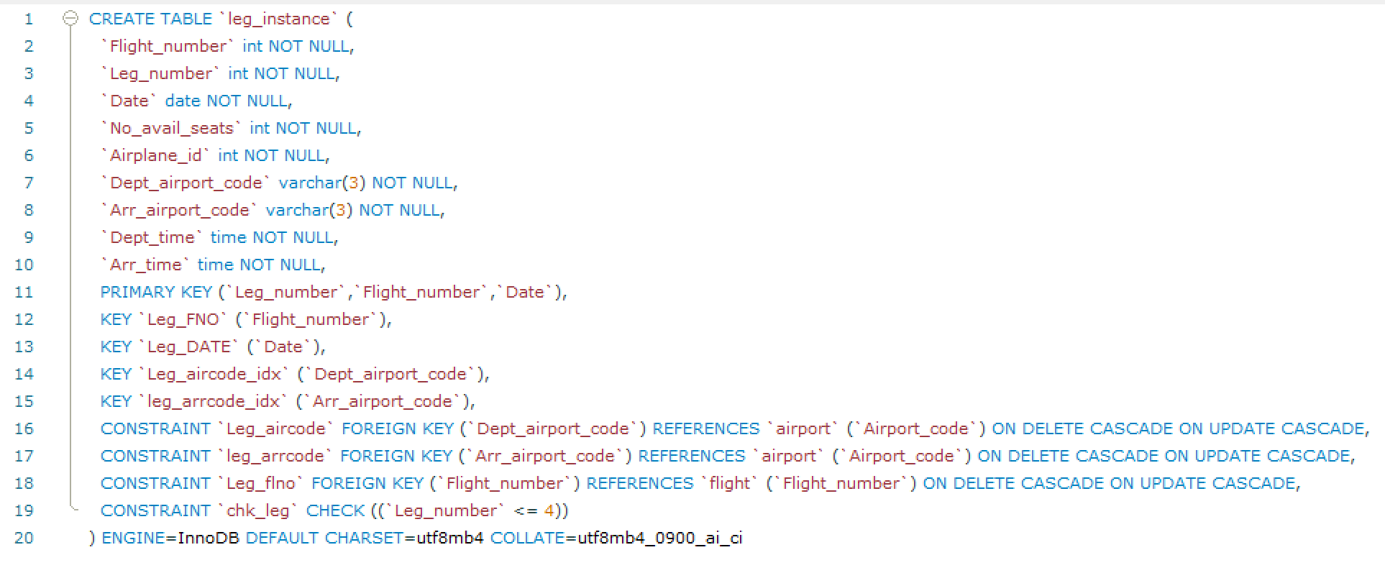
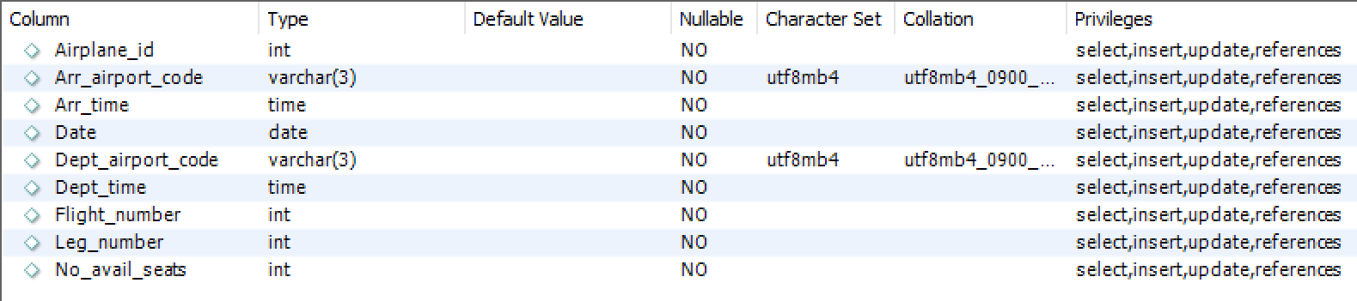
SEAT_RESERVATION
